TEST CASE 2 POI REPORT

*CVM Test Case 2 V48*

Table of Contents

Equations for Single-building Reductive 2

POI7 3

POI 11 4

## Equations for Multiplicative

See flow chart and multiplicative library

## POI31 - 1d3dd7d3-e56f-4746-a59a-c9d47c797712

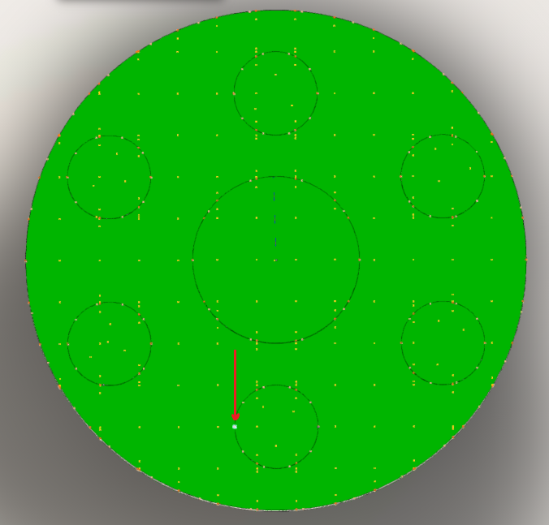

This point is an edge-oval point. There appears to be a secondary point stacked upon the original point. The point appears to be mislabeled as edge-straight in the model by the creator of the model:

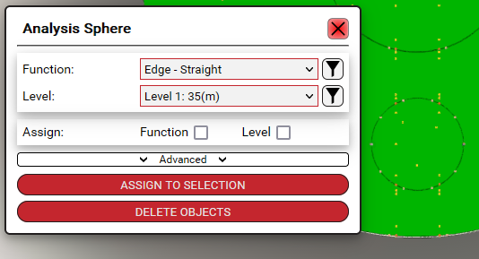

The JSON appears to have some incorrect inheritence:

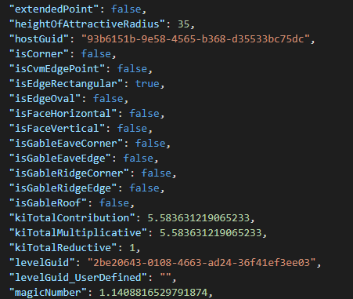

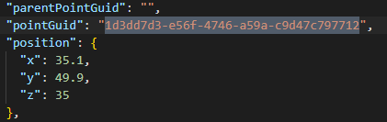

These are the numbers that are shown on the LPSD model.

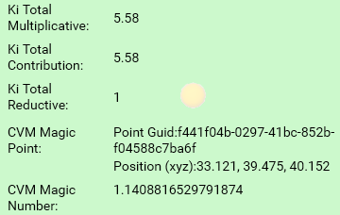

## POI32 - f5a62239-fdc8-431f-bf26-d7c6fc693ce5

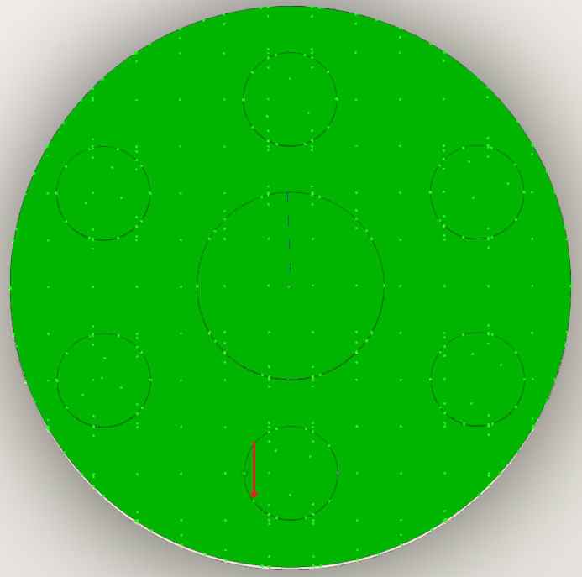

This point is an edge-curved point.

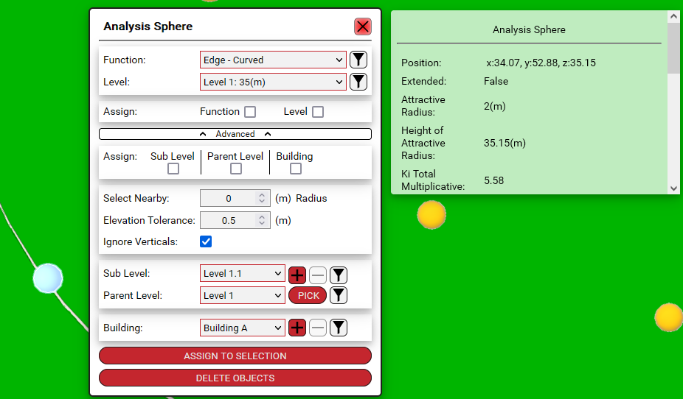

There was a slight calculation error on my end for equation N, that bug was resolved to calculate the new N value of 1.740652.

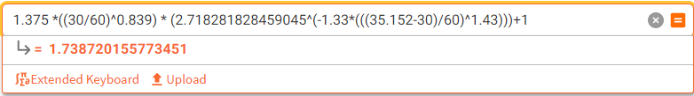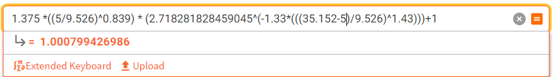

There was a typo issue for equation D that accidentally pulled equation B instead, that typo was resolved.

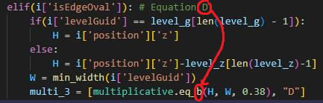



## POI36 - d5a4e224-7634-4c73-bbc7-961eee1ab024

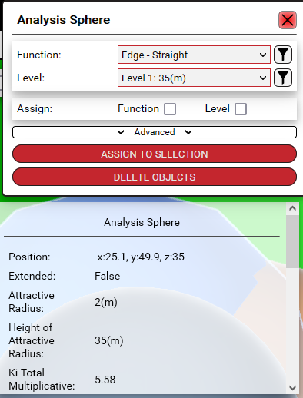

Many points are listed as edge-straight which is incorrect so there will be additional changes to the following GUID points:

1d237dbb-7fa1-4ec6-8f4a-09645d0e6da0

44619f62-6f1f-481b-9c88-5c2947288401

d8aa9384-147b-4582-8cea-433928b95791

61cafe4d-5f17-48d2-833f-f849a5ac6f21

dff4d20d-faf2-4c42-a9ed-705c1fbc974c

146eeacf-b402-44e0-af08-c367c7131c86

c0fe0d80-483d-4e32-937a-654674d631fc

a3650311-09c6-4131-a3cd-a984cd491c93

## POI 11

POI 11 has several POIs on top of each other. Discerning the proper point yeilds 0 for the reductive however another point nearby has the correct reductive values.

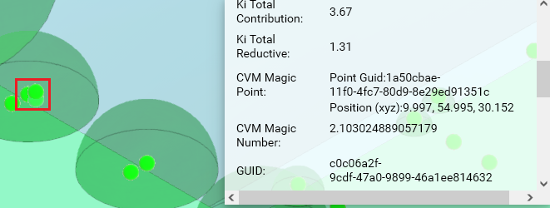



If the analyze form tool is utilized at 1000x1000 spacing the additional points are removed. The manually placed point that is remaining still yeilds 0 for its result on both multiplicative/reductive.

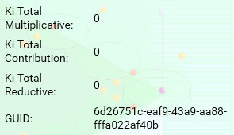

If the point is removed and a new point is created the x, y, z coordinates are significantly different than the original point:

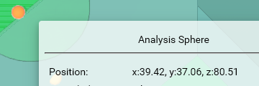

The new point also yeilds 0 for its reductive result despite requiring a reductive value. The coordinates for the POI should be:

